Windows command line operations, from standard keyboard input.

**Input screen:- welcome screen**

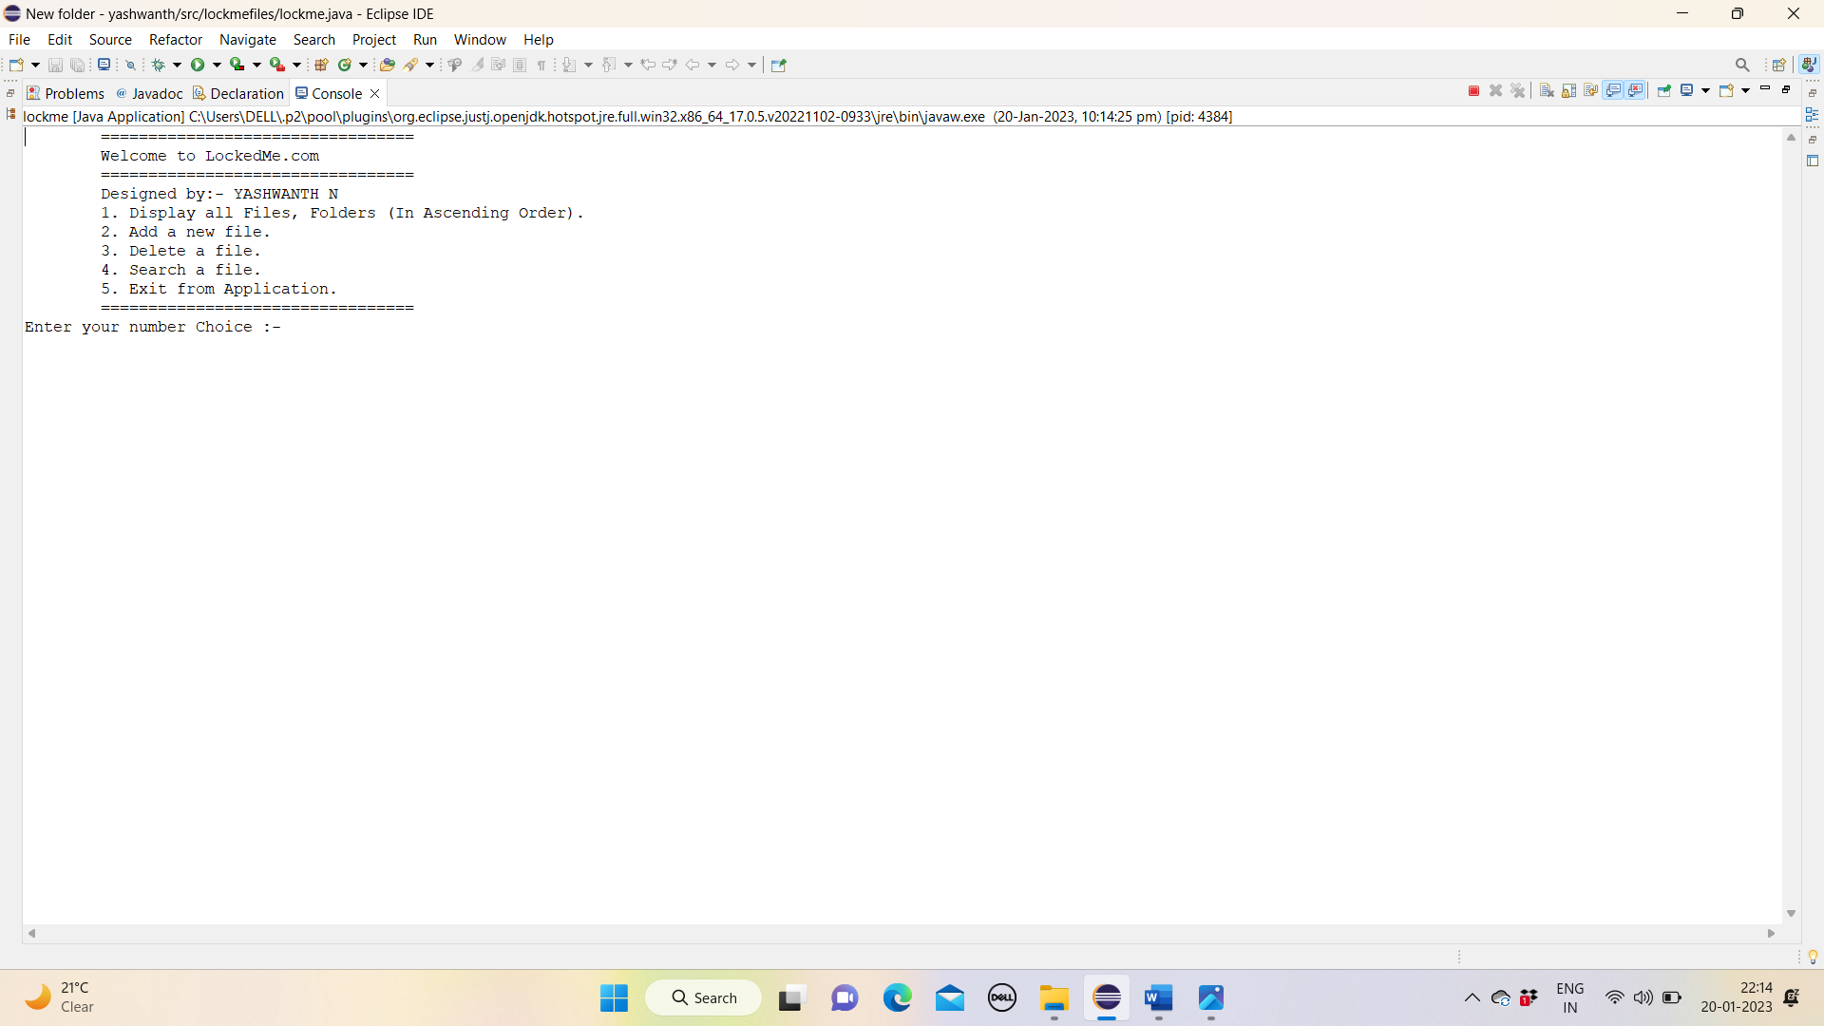

**output screen:-1 Display all Files, Folders (In Ascending Order).**

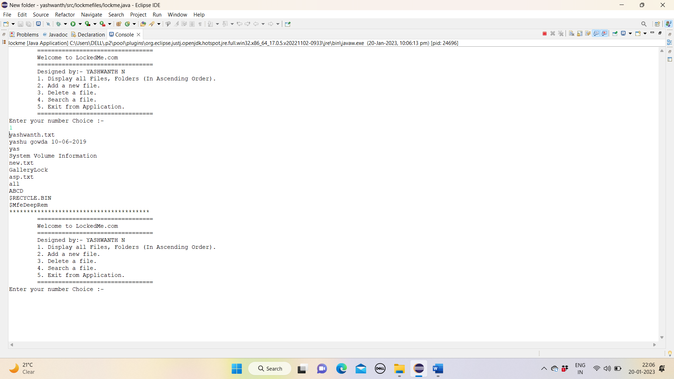

**output screen:-2 (**Add a new file in given projectFilesPath)

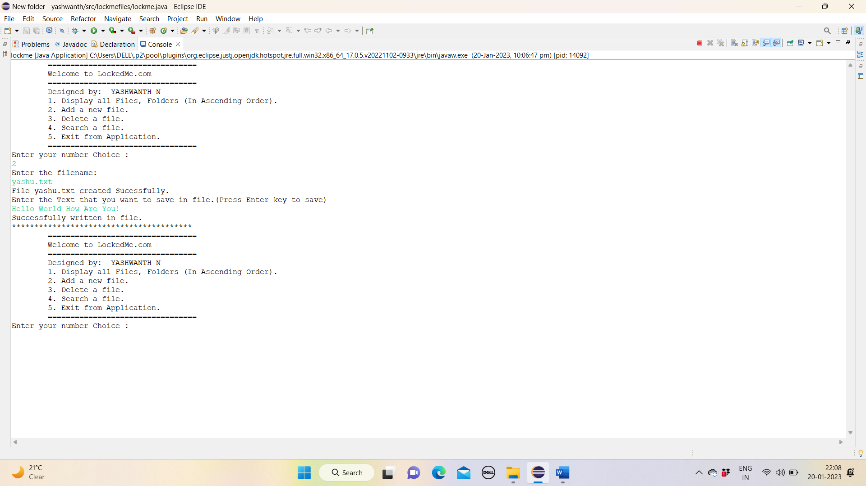

**output screen:-3(**Delete a file**)**

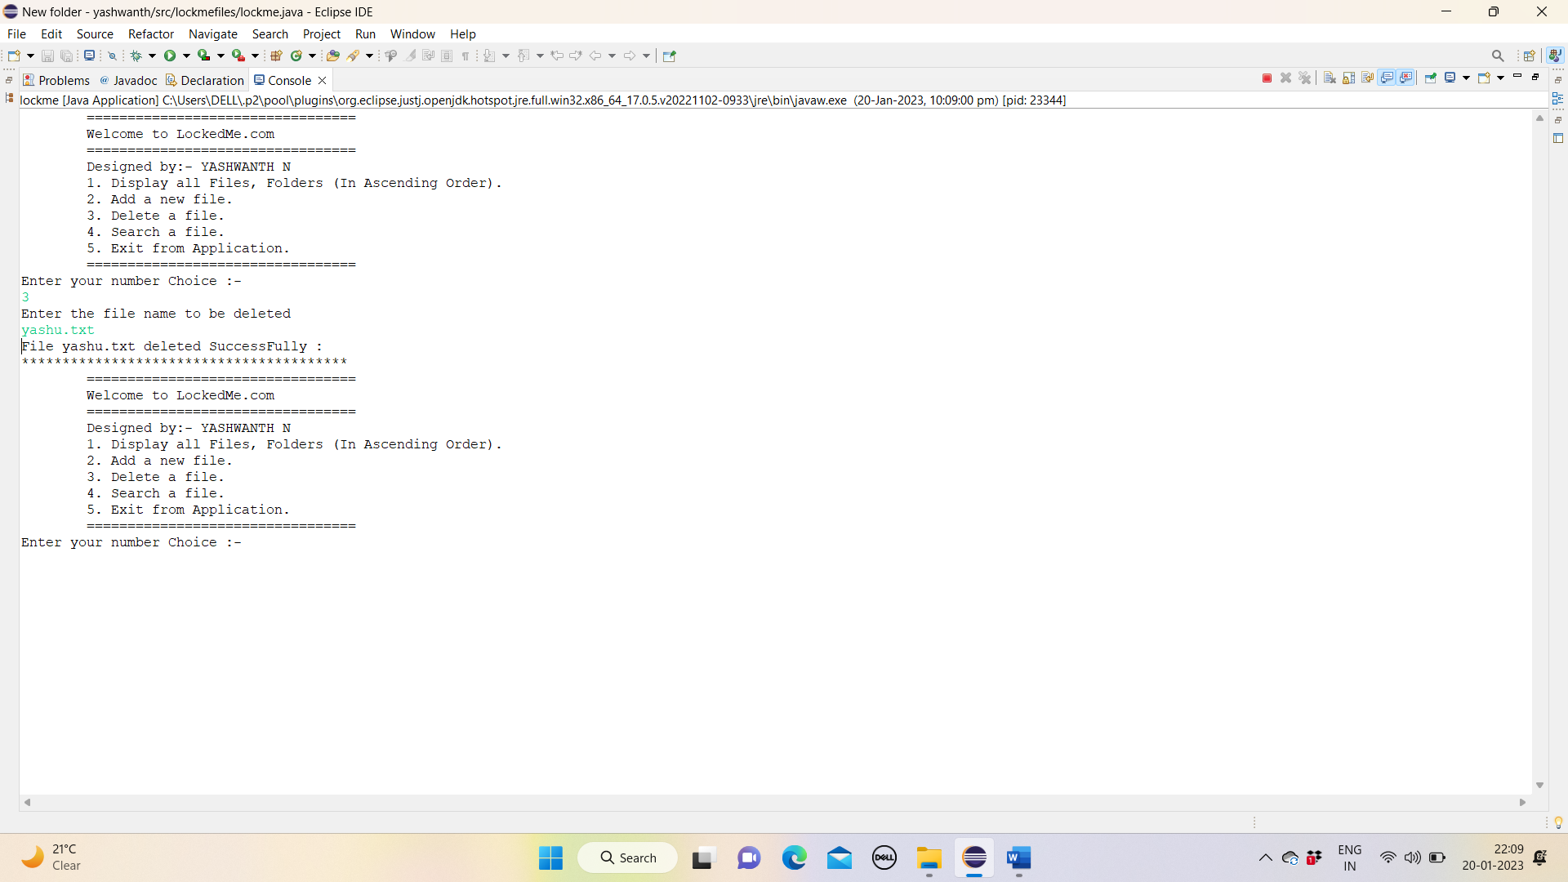

**output screen:-4(**Search a file.**)**

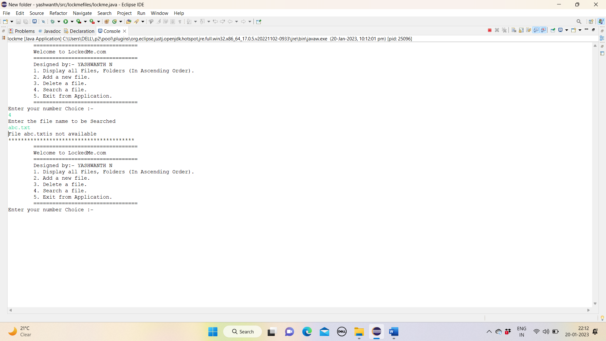

**output screen:-5(**Exit from Application.**)**

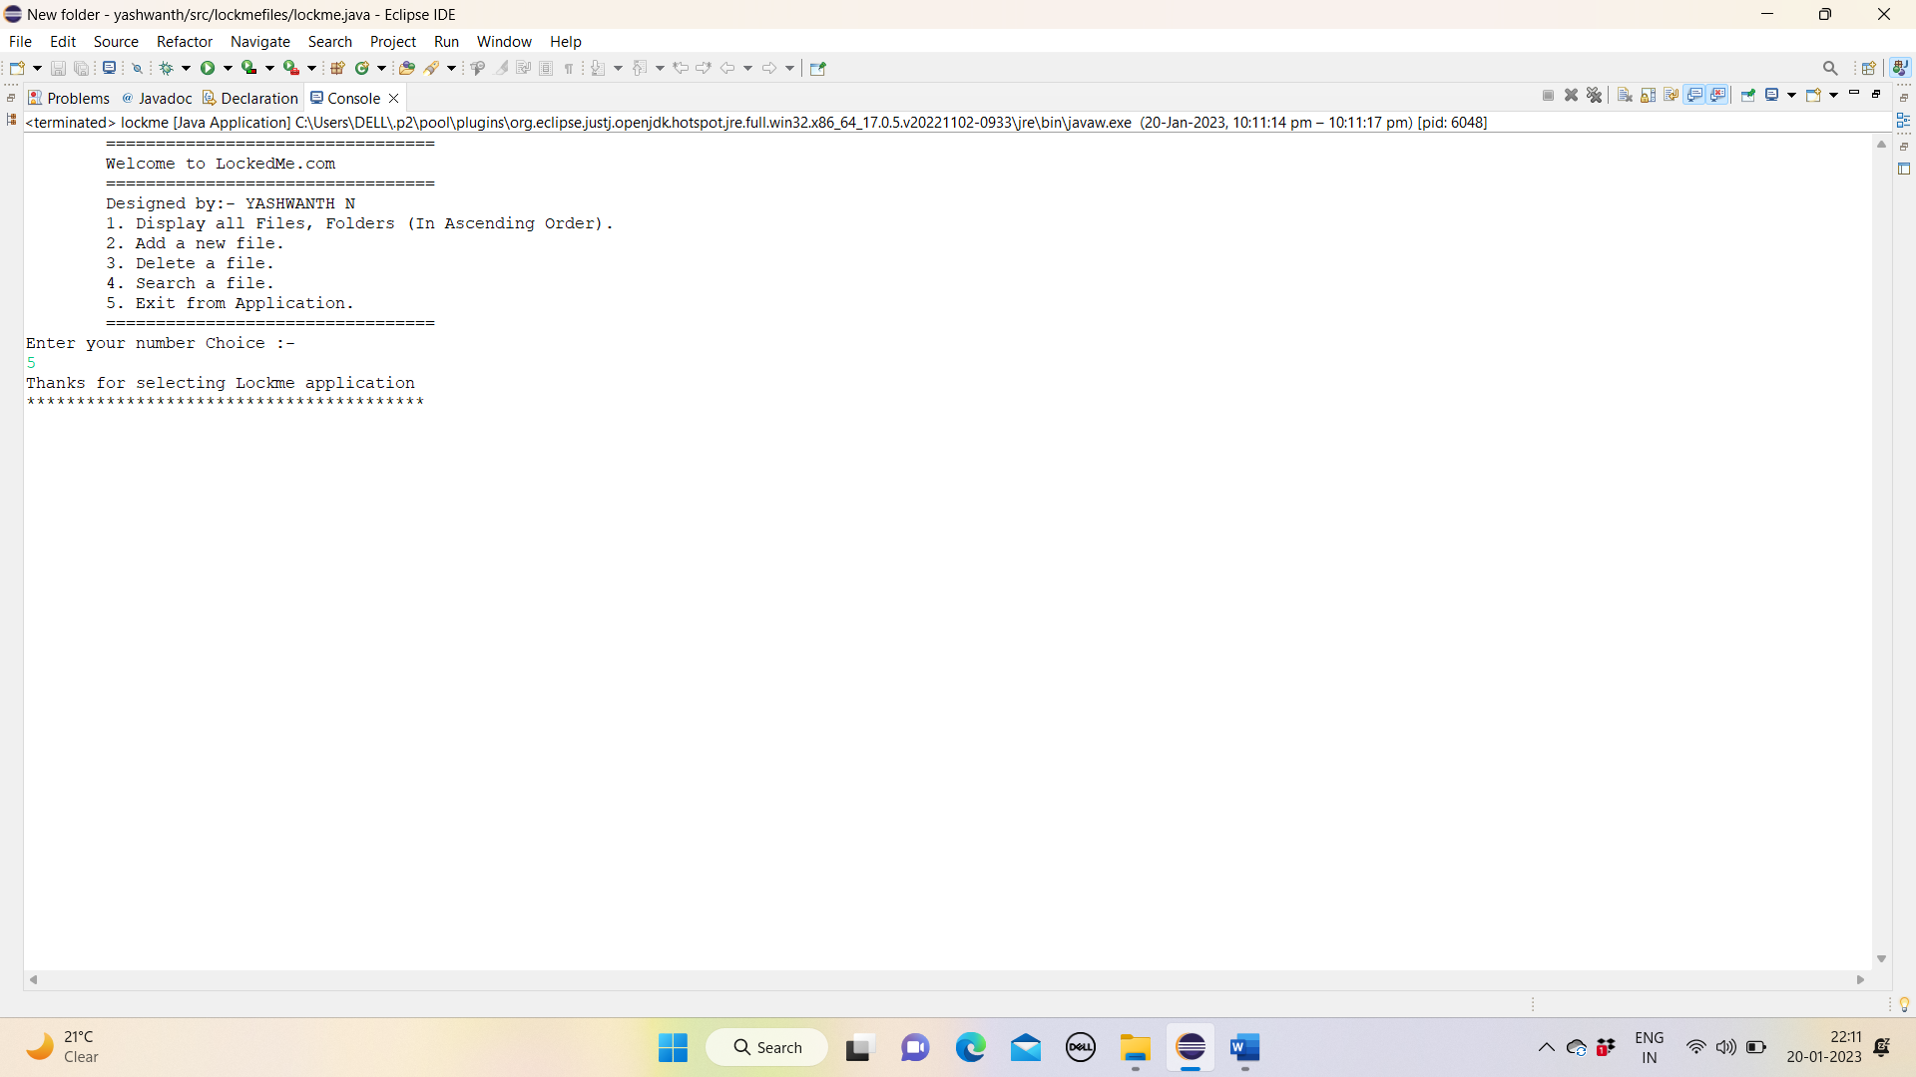

**output screen:-5(**File not found.**)**

